7*24 hour Unmanned Grocery Store System
Design and Implementation Proposal
Nan Zhou & Hoang Truong Pham

Abstract: This document covers the system design and implementation for the 24-hour Unmanned Grocery Store System.

Table of Contents
1 Introduction 2
1.1 Business Need 2
1.2 Prodcut / System Vision 2
2 Budget 2
2.1 Cost Benefit Analysis 2
3 System Analysis and Design (UML diagrams) 3
3.1 Usecase Diagram 3
3.2 Activity Diagram (If any) 3
3.3 Sequence Diagram (If any) 3
3.4 Entity Relationship Diagram 3
3.5 Class Diagram 3
3.6 State Diagram (If any) 3
4 Agile Development Lifecycle 3
4.1 User Requirements (Stories) 3
4.2 Product Backlog Proritization 3
4.3 Story Points 3
4.4 Sprint Planning 4

Introduction

Business Need
Background:
I have a part time job in a grocery store at Montreal. The store is opening from 10am to 11pm every day. During weekends, it is opening until 2am. When I talked with the owner, I found that it has some demands which need to be solved.
- It is difficult to hire employees. Because the shortage of labor market of Montreal and the low salary, it is difficult to hire enough employees to work for them.
- The cost for hiring is high. Although it is the minimum wage of Quebec ($14.25) the owner offers, to a small grocery store, it is still a high cost which reduce their profit.
- The opening hours is limited. The owner wants to extend its opening hours to 24-hour to increase the profit. However, because the problem 1 and 2, they can’t do it.
- The owner has another business, but because the problem 1, they must stay in the store whole day, and they don’t have time to replenish goods. Thus, it has influence on their sales. Then there isn’t enough goods or lack of goods, it reduces their profit. Meanwhile, the owner can’t release himself to deal with his other business.
- Steal in the store happens frequently. Although there is the monitor system in the store, when crowed people inside, the owner or the employee doesn’t have time to pay attention to the monitor.
Based on these demands, we suggest using a 7*24 hour unmanned grocery store system. It can solve most of the problems.
- Using this system, the owner doesn’t worry about hiring employee, whenever the season, time, the shortage of labor market.
- The owner can save the cost of hiring employee, in order to increase their profit.
- With this system, the store can open 24-hours, which will increase the revenue.
- The owner can be released with this system, so that he can replenish goods in time. He also can deal with the other business or even have a good rest.
- The system with AI technology can identify the people who stole things

Prodcut / System Vision
This system is made of three main sub-system.
- Electronic price tag system
Owner can control the price tag remotely. He can set and change the price at a preset time.
For example, some fruits, vegetables, and food, in the evening they are not as fresh as morning. Owner can set as after 9pm, these goods’ price can have 20-30% discount to speed up for sale.
The electronic price tag can automatically display the discount and new price. For some popular goods, or special holidays, the price maybe rise a little bit, so that the owner can have the maximum profit.
- Self-service checkout system
Using this system, the customers can scale the goods and pay the bill by themselves. This system is similar as it in most of the supermarket now. And we also add a new payment—face pay. Customers can choose to bind their credit or debit card with their face registered in our database. Thus, customers don’t need to bring any cards or even cell phone. They can choose using their face pay. Once they choose this method, system will scan their face and compare with data stored in database. If match, system will use the card information they already blinded to request money from their bank.
- Security system
The security system can protect the properties of owner as much as possible.
When a customers want to enter in the store, system will scan their faces, then compare with database to verify if they are in the blacklist. If so, the door won’t be opened, and an alarm will send to the owner.
When the customers are in the store, AI will be monitoring their actions. If they have three actions of pick-up goods but they only scan two items. System will keep a record of him and send an alarm and a video record to the owner, and let the owner decide if put him in a blacklist and lock the door.
Our Vision:
To liberate the productivity of the owner of depanneur and make profit as more as possible.

Budget

Cost Benefit Analysis
For hiring employee salary cost (consider as benefit):
Working Hours per week is 5*4+8*3=20+24=44
For 24 hours opening extra working hours per week is 10*4+8*3=64
Working hours per year is (44+64)*52=5616
Quebec minimum wage $14.25
Total yearly salary cost: 5616*14.25=80028

For deploy new system cost:
Hardware and Software Costs: $50000
Maintenance Costs per Year: $10000
Discount rate: 12%
Lifetime of System: 6 years

- Net Present Value
Cost | Year 0 | Year 1 | Year 2 | Year 3 | Year 4 | Year 5 | Year 6
Dev Costs | $50,000 | $0 | $0 | $0 | $0 | $0 | $0
Op Costs | $0 | $10,000 | $10,000 | $10,000 | $10,000 | $10,000 | $10,000
PV | 1.00 | 0.89 | 0.80 | 0.71 | 0.64 | 0.57 | 0.51
T adj Costs | $50,000 | $8,900 | $8,000 | $7,100 | $6,400 | $5,700 | $5,100
Sum Cost | $50,000 | $58,900 | $66,900 | $74,000 | $80,400 | $86,100 | $91,200
Benefits | $0 | $80,028 | $80,028 | $80,028 | $80,028 | $80,028 | $80,028
PV | 1.00 | 0.89 | 0.80 | 0.71 | 0.64 | 0.57 | 0.51
T adj Benefits | $0 | $71,225 | $64,022 | $56,820 | $51,218 | $45,616 | $40,814
Sum Benefits | $0 | $71,225 | $135,247 | $192,067 | $243,285 | $288,901 | $329,715
Net Benefits-Costs | -$50,000 | $12,325 | $68,347 | $118,067 | $162,885 | $202,801 | $238,515

- Payback Period
Payback period = 50000/(50000+12325)=0.80
- ROI
ROI=238515/91200=2.61

System Analysis and Design (UML diagrams)

Usecase Diagram
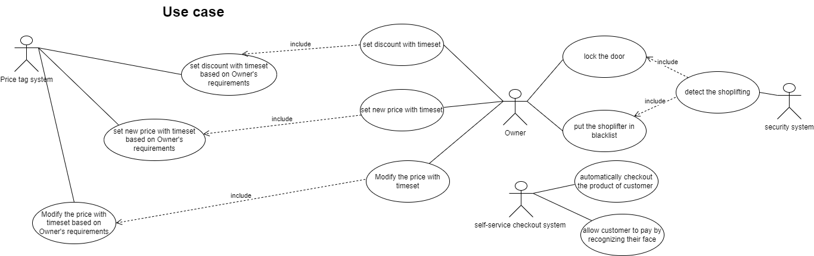

Activity Diagram (If any)
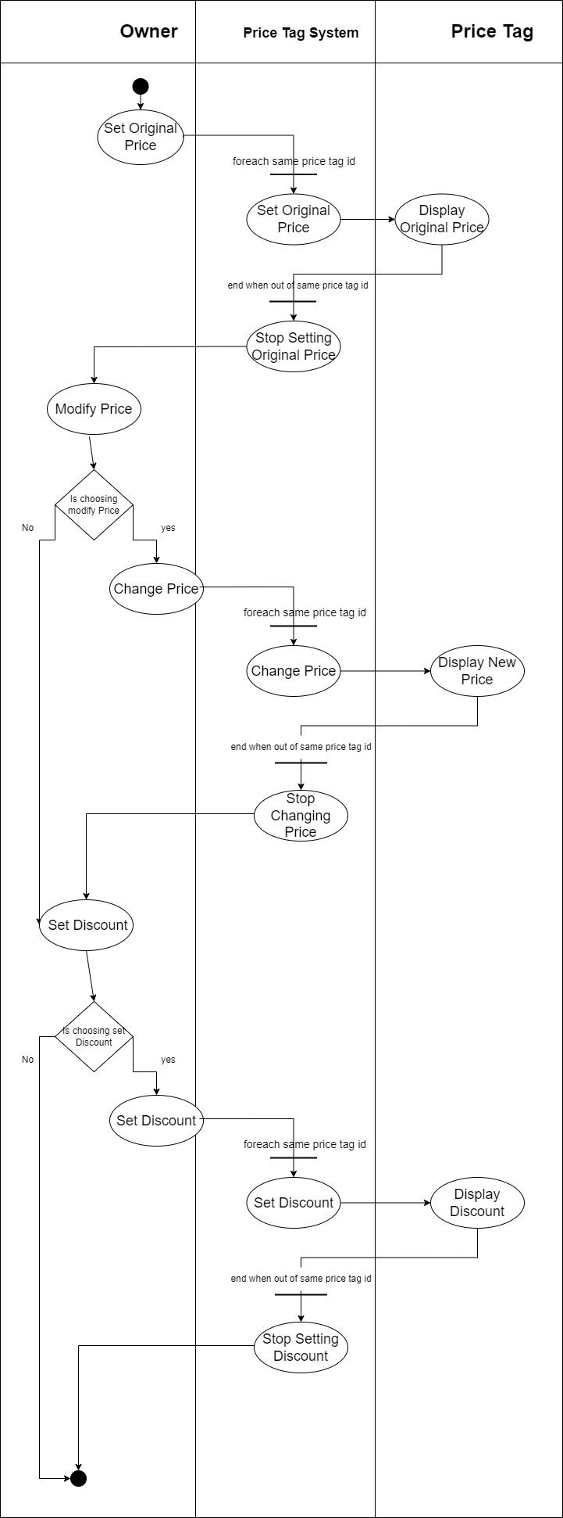

Sequence Diagram (If any)
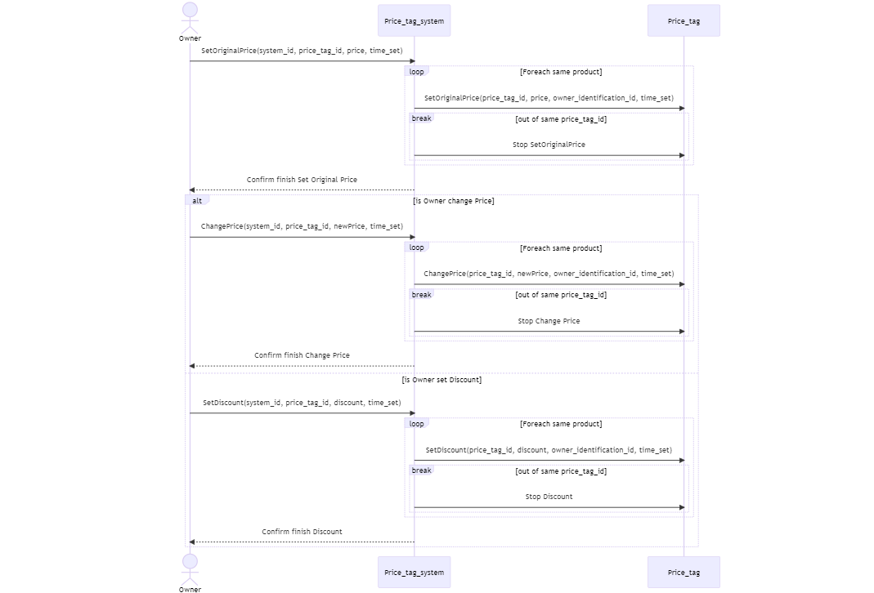

Entity Relationship Diagram
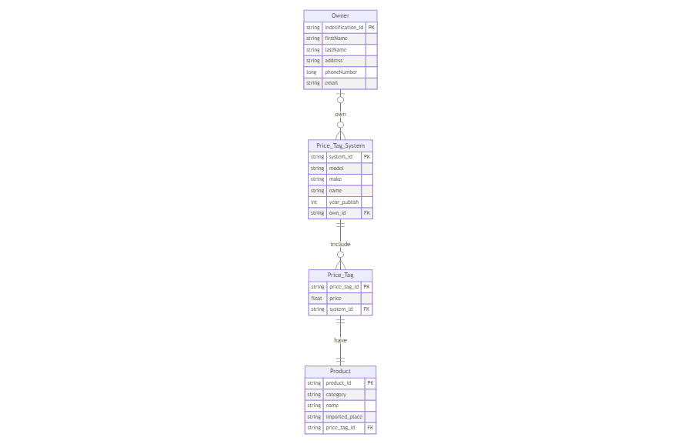

Class Diagram
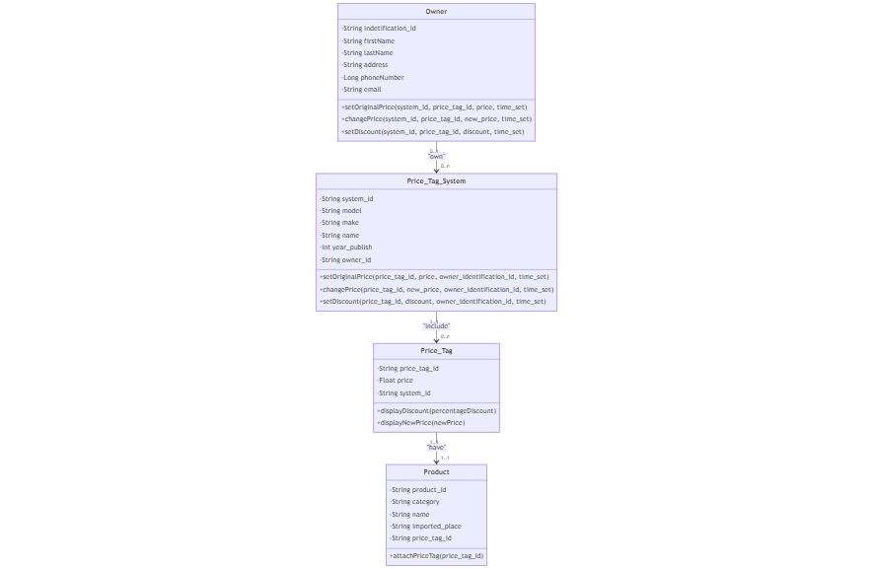

State Diagram (if any)

Agile Development Lifecycle
7*24 hour Unmanned Grocery Store System - Roadmap - Jira (atlassian.net)

User Requirements (Stories)
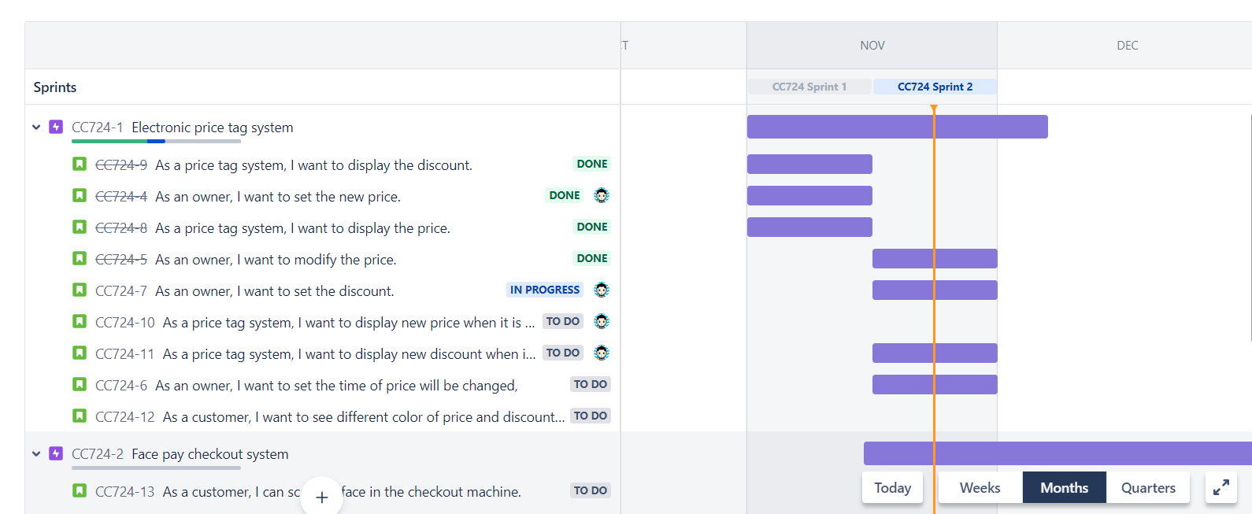
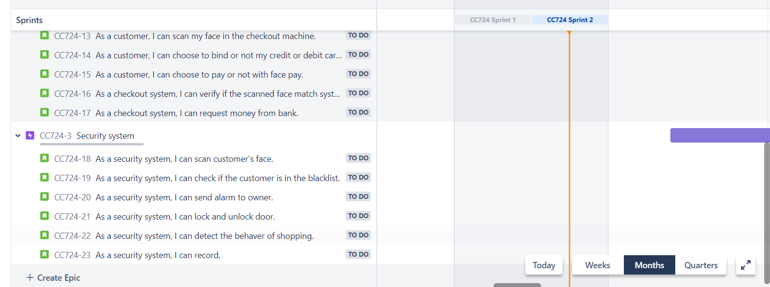

Product Backlog Proritization
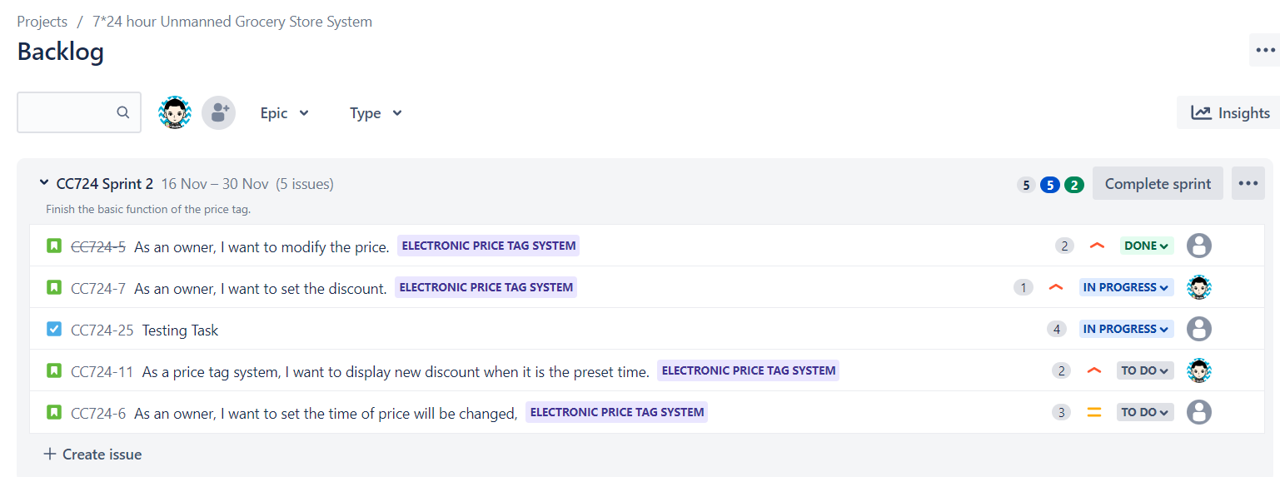

Story Points

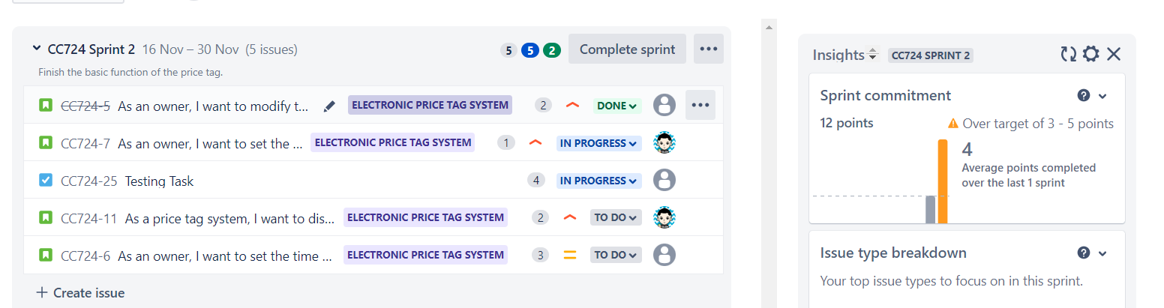

Sprint Planning
